Chinese Film Summaries

Bilingual Songs: English – Mandarin Chinese Audio CD Vol.1 (2009)
Students will have fun singing in English and Mandarin as they learn the English and Pinyin alphabet, counting to ten, days of the week, months of the year, weather and seasons, colors, food, about the Chinese zodiac, parts of the body, articles of clothing and members of the family.

Chinese Box (1997)
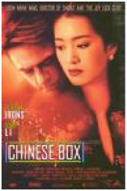
99 minutes
John is an English photojournalist who has spent over a decade in Hong Kong; his friend Jim often crashes in his cramped apartment. John's unrequited love is Vivian whom he aches for but has not the nerve to possess. Concurrent with England's transfer of Hong Kong back to the Chinese, John discovers that he has a rare form of leukemia and has only months to live. So John, Jim, and the disfigured proto-hippy Jean grab a digital video camera and prowl the streets, seeking to document the "real" Hong Kong one last time.

Eat Drink Man Woman (1994)
124 minutes
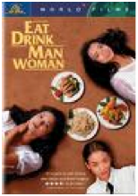
Senior Master Chef Chu lives in a large house in Taipei with his three unmarried daughters, Jia-Jen, a chemistry teacher converted to Christianity, Jia-Chien, an airline executive, and Jia-Ning, a student who also works in a fast food restaurant. Life in the house revolves around the ritual of an elaborate dinner each Sunday, and the love lives of all the family members.

Great Wall, A (1986)
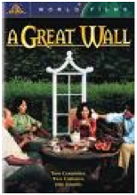
102 minutes
When computer programmer, Leo Fang, is passed up for promotion, he feels it is because he is Chinese, and quits. He takes his Chinese-American family to Mainland China to visit his relatives, the Chao's for a vacation. The clash of cultures, between the men, wives, and teenagers, leads to some confusion, and misunderstanding.

Hero (2002)
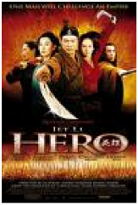
99 minutes
In ancient times China was divided into seven kingdoms. Qin, the king of the western most province, is under permanent threat of assassination attempts. His greatest fears are the warriors "Broken Sword", "Flying Snow" and "Sky". One day one of the magistrates of his kingdom enters the palace, claims that he defeated all three of the emperor's adversaries and tells his story; how he beat "Sky" in a duel and used the love between "Broken Sword" and "Flying Snow" to subdue them.

Integrated Chinese (2010)
180 minutes
The Intergrated Chinese DVDs bring the popular Cheng & Tsui textbook series to life in a whole new way! Presenting lively, humorous dramatizations of all dialogues and narratives in the Level 1, parts 1 and 2 textbooks. The stories follow a goup of college classmates, Wand Peng, Li You, Gao Wenzhong, Bai Ying’ai and their friends. Each dialogue is in the book so students can easily follow along with the text. Each DVD has optional subtitles in simplified, traditional, pinyin and English. Each chapter also includes additional “culture minuets.”
Raise the Red Lantern (1991)
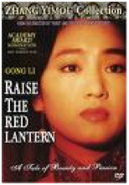
125 minutes
After her father's death, nineteen-year-old Songlian is forced to marry Chen Zuoqian, the lord of a powerful family. Fifty year old Chen has already three wives, each of them living in separate houses within the great castle. The competition between the wives is tough, as their master's attention carries power, status and privilege. Each night Chen must decide with which wife to spend the night and a red lantern is lit in front of the house of his choice. And each wife schemes and plots to make sure it's hers. However, things get out of hand...

Sent Down Girl, The (1998)
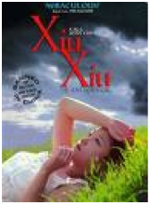
93 minutes
Young teen girl Xiu Xiu is sent away to a remote corner of the Sichuan steppes for manual labor in 1975 (sending young people to the country side was a part of Cultural Revolution in China). A year later she's sent even further to the more remote spot with a Tibetan saddle tramp Lao Jin to learn horse herding. There, Xiu Xiu falls in love with a man who promises to talk to an official and get her back home. He brings an apple, which Xiu Xiu treasures. While waiting for him to return another man comes claiming to be his friend and brings another apple. After him another man comes and by that point she is reduced to a hooker.

The Soong Sisters (1997)
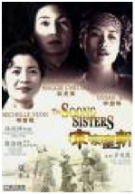
145 minutes
The Soong family was a political dynasty in China that reached the highest levels of power. This film follows the lives of the three Soong daughters, who were educated in America and returned to China. Ai-ling (the oldest) married a wealthy and powerful businessman. Ching-ling married Sun Yat-sen, the revolutionary founder of modern China. Mei-ling (the youngest) married Chiang Kai-shek, China's leader during World War II. The sisters captured the world's fascination for their brilliant marriages and their strong influence on their nation.

Story of Qiu Ju, The (1992)
100 minutes
A pregnant peasant woman seeks redress from the Chinese bureaucracy after the village chief kicks her husband in the groin in this comedy of justice. As she is frustrated by each level of the hierarchy and travels farther and farther away from the countryside the viewer is also provided with a look at the changing Chinese society through the verite camera used in most scenes.

Summer Palace (2006)
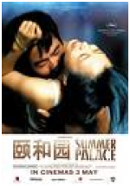
140 minutes
Country girl, Yu Hong, leaves her village, her family and her lover to study in Beijing. At university, she discovers an intense world of sexual freedom and forbidden pleasure. Enraptured, compulsive, she falls madly in love with fellow student Zhou Wei. Driven by obsessive passions they can neither understand nor control, their relationship becomes one of dangerous games - betrayals, recriminations, and provocations - as all around them, their fellow students begin to demonstrate, demanding democracy and freedom. Protests collapse, and Yu and Zhou lose each other amidst the social chaos and panicked crowds. Zhou Wei is sent to a summer military camp, and on his release moves to Berlin, fleeing both his country and memories of Yu. She finds a job, a lover, but cannot forget Zhou.

To Live (1994)
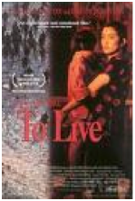
133 minutes
Fugui and Jiazhen endure tumultuous events in China as their personal fortunes move from wealthy landownership to peasantry. Addicted to gambling, Fugui loses everything. In the years that follow he is pressed into both the nationalist and communist armies, while Jiazhen is forced into menial work. They raise a family and survive, managing "to live" from the 40's to the 70's in this epic, but personal, story of life through an amazing period.

Together (2002)
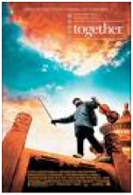
120 minutes
Young violinist Xiaochun and his father move from their small, provincial town to Beijing so Xiaochun can audition for a prestigious music academy. Their new life is unfamiliar but full of promise, allowing the young man to truly figure out which direction he wants to take in life.

World Without Thieves, A (2004)
100 minutes
Two grifters, Wang Bo and Wang Li, a couple who've been arguing, board a train in rural China. He wants to fleece a peasant, nicknamed Dumbo for his naiveté, who's carrying 60,000 yuan and trusts everyone. She wants to protect the hick kid, an act of expiation brought on by prayer and a visit to a temple. Also on board are one of more sets of thieves, including a calculating boss and his femme fatale. The boss wants to recruit Wang Bo, and a series of contests ensue, with the potential of turning deadly. While Li guards Dumbo from Bo and the others, can she and Bo sort out their relationship? And can Dumbo's simple spirituality touch anyone else?

