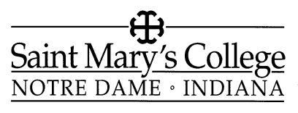
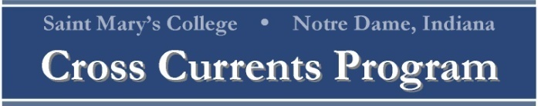

Faculty Development and Indiana Connections Grant

Please submit this application form along with your proposal and supporting materials.

Name _________________________________ Signature_______________________________________

Title/Rank_____________________________ Department ___________________________________

Campus Address _______________________ Phone ___________________________________

Home Address _____________________ Phone ___________________________________

Course/Project Title __________________________________________________________

Education: Indicate the highest degree you hold, along with any other information about your education relevant to your project.

_______________________________________________________________________________________
_______________________________________________________________________________________

Proposal - please address the following:
For course proposal
  - Description of course (if restructuring or updating a course, the previous syllabus must be included for comparisons to be made on the update)
  - Course learning outcomes and aims (please review the Learning Outcomes which are included on the Grant Overview sheet)
  - Description of community partner
  - How proposal will form a mutually beneficial relationship with a community organization and develop Indiana connections for students
  - How course will assist students’ exploration of the four critical questions (listed on Grant Overview sheet)
  - Plan for sustaining this course upon completion of the grant (include any costs that may be related to this course)
  - Assessment plan for learning outcomes and course effectiveness
  - Timeline for implementation of this new or revised course

For project proposal
  - Description of project
  - Expected learning outcomes and aims for students participating in this project (please review the Learning Outcomes which are included on the Grant Overview sheet)
  - Description of community partner
  - How proposal will form a mutually beneficial relationship with a community organization and develop Indiana connections for students
  - How project will assist students’ exploration of the four critical questions (listed on the Grant Overview sheet)
  - Plan for sustaining this project upon completion of the grant (include any costs that may be related to this activity)
  - Assessment plan for learning outcomes and project effectiveness
  - Timeline for implementation of this project

Recommendations

Community Partner: Please ask your community partner to write a letter of recommendation addressing the significance of your proposal and your ability to complete it. Letters may be submitted to: Career Crossings Office, 114 Spes Unica, Saint Mary’s College, Notre Dame, IN 46556. Applicants should ensure that the letter(s) reaches the Committee by Thursday, March 29 at 5pm.

Name of community partner: ______________________________________________________________

Department Chair or Director: Please ask your department chair or director to sign the following endorsement addressing the significance of your proposal in addition to writing a brief letter of recommendation on your behalf.

Endorsement:
I have read this proposal and consider that it is consistent with the interests of the department and the College and is sustainable with the current resources in the department.

___________________________________________________________________________________
Department Chair or Director Date

Other funding:

Do you have other financial support secured for this course/project?

Yes No

If yes, please explain.

___________________________________________________________________________________

If no, are you attempting to obtain support for the course/project from sources other than this fund?

Yes No

If yes, list with disposition (pending or denied):

___________________________________________________________________________________

Semester in which the course/project will occur: _______________________________

NOTE: Grant recipients are expected to submit two (2) reports on the course/project to the Career Crossings Office on this timeline:

May 1, 2013 Brief progress report due
December 12, 2013 Wrap-up of grant activities/final report
(or sooner if applicable)

Reports may be emailed to Maureen Baska at mbaska@saintmarys.edu.

The Committee wishes to make successful proposals available to serve as models for other faculty interested in applying for these grants. If your proposal is funded, may we make it available to future applicants?

Yes No

