Haine, La 95 minutes

The film follows three young men and their time spent in the French suburban "ghetto," over a span of twenty-four hours. Vinz, a Jew, Saïd, an Arab, and Hubert, a black boxer, have grown up in these French suburbs where high levels of diversity coupled with the racist and oppressive police force have raised tensions to a critical breaking point. During the riots that took place a night before, a police officer lost his handgun in the ensuing madness, only to leave it for Vinz to find. Now, with a newfound means to gain the respect he deserves, Vinz vows to kill a cop if his friend Abdel dies in the hospital, due the beating he received while in police custody.

Halfouine (1990) 95 minutes

A coming-of-age comedy/drama set in Tunisia. Twelve-year-old Noura is an impressionable boy who must learn to reconcile two conflicting worlds - the loving world of Moslem women and the vastly different, harsher world of men - while also dealing with his own budding sexuality.

Hiroshima, mon amour (1959) 95 minutes

While shooting an international movie about peace in Hiroshima, a married French actress has a torrid one-night stand with a married Japanese architect. They feel a deep passion for each other and she discloses her first love in times of war in the French town of Nevers to him. He falls in love with her and asks her to stay with him in Hiroshima.

Honneur d’un Capitaine (1982) 110 minutes
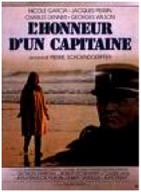
A courtroom-drama about a dead Captain whose memory is publicly accused by a historian on TV, twenty years after his death. The story follows his widow's struggle to prove that he wasn't a murderer and didn't practice torture while he was leading a ground unit during the Algeria war. She decides to sue the man and thus begins an investigation which retraces the Captain's last 2 weeks, day by day.

Hussard sur le Toit, Le (The Horseman on the Roof) (1995) 135 minutes
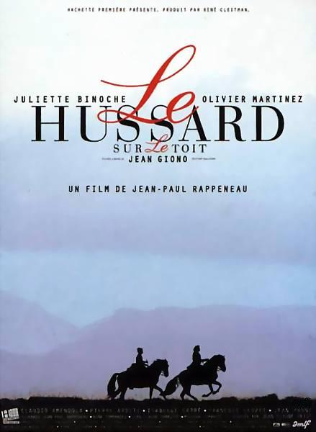
Le Hussard is an Italian master horseman and swordsman who has left his mother in Italy to gather funds for the revolutions against Austria. Seems to be some time delays as the revolution was a little later, maybe he didn't collect as much as was necessary to form the government that the wealthy and educated Italians wished for. In the 1830's, Giuseppe Mazzini organized the La Giovine Italia, an organization, which supported several failed insurrections in various parts of Italy. It was probably one of these and the film doesn't address them, having the action in France and essentially dwelling upon the actors and their relationship.

Inch’Allah Dimanche (Inch’Allah Sunday) (2001) 98 minutes

The story of an immigrant woman struggling against old world traditions. Zouina leaves her homeland with her three children to join her husband in France, where he's been living for the past ten years. In a land and culture foreign to her, Zouina struggles against her mother-in-law's tyrannical hand and her husband's distrustful bitterness in an attempt to adjust to her life in exile.

Indochine (1992) 155 minutes

A story of romance and separation told through the backdrop of a country in turmoil. The film centers on the relationship of the beautiful and imperious Eliane, a French rubber-plantation owner, and Camille, her adopted Indochinese daughter. The mother and daughter are very close until a diffident naval officer, Jean-Baptiste enters their lives. Eliane is in love with him, but Jean-Baptiste and Camille become attracted to each other and fall in love. Thinking that she is doing Camille a favor, Eliane arranges to have Jean-Baptiste transferred to the far-away Tonkin Islands. But Camille flees the plantation to go to the man she loves. As she travels the country, she gains a greater knowledge and respect for the people of her homeland.

Jean de Florette (1986) 120 minutes

In a rural French village an old man and his only remaining relative cast their covetous eyes on an adjoining vacant property. They need its spring water for growing their flowers, so are dismayed to hear the man who has inherited it is moving in. They block up the spring and watch as their new neighbor tries to keep his crops watered from wells far afield through the hot summer. Though they see his desperate efforts are breaking his health and his wife and daughter's hearts they think only of getting the water.

Jésus de Montréal (1989) 119 minutes

A group of actors putting on an interpretive Passion Play in Montreal begin to experience a meshing of their characters and their private lives as the production takes form against the growing opposition of the Catholic church.

Jeux Interdits (1952) 81 minutes

A young girl is orphaned in an air raid while fleeing a French city with her parents early in World War II. A peasant boy befriends her after she wandered away from the other refugees, and is taken in for a few weeks by his family. The children become fast friends, and the film follows their attempt to assimilate the deaths they both face, and the religious rituals surrounding those deaths, through the construction of a cemetery for all sorts of animals.

Joan the Maid – The Battles (1994) 160min
Joan the Maid – The Prisons (1994) 176min


The Battles:
A part of Joan of Arc's life. At the beginning, Jeanne (Joan) has already left Domremy, she is trying to convince a captain to escort her to the Dauphin. It ends during Jeanne's first battle, at Orleans. Meanwhile, Jeanne is depicted more as a warrior than a saint (all cliches are avoided), with only her faith for strength.
The Prisons:
The latter part of Joan of Arc’s life.

Jules et Jim (1962) 105 minutes

In Paris, 1900, two friends, Jules (Austrian) and Jim (French) fall in love with the same woman, Catherine. But Catherine loves and marries Jules. After WWI, when they meet again in Germany, Catherine starts to love Jim... This is the story of three people in love, a love that does not affect their friendship, and about how their relationship evolves with the years.

Liasons Dangereuses (Dangerous Liasons) (1988) 119 min

Set in France around 1760-1770. The Marquise de Merteuil needs a favor from her ex-lover, Vicomte de Valmont. One Marquise de Merteuil's ex-lover, Gercourt, is planning on marrying a young, virtuous, woman called Cecile de Volanges. The Marquise would like Valmont to seduce Cecile before her wedding day. Meanwhile Valmont has a conquest of his own in mind, Madame de Tourvel, a beautiful, married, and God fearing woman. The Marquise doesn't think that Valmont can do it, she tells him that if he can provide written proof of a sexual encounter with Madame de Tourvel, that she will offer him a reward, one last night with her. But Valmont will find himself falling in love with Mrs. de Tourvel, embracing the deadly jealousy of the marquise de Merteuil.

Long Dimanche de Fiancailles, Un (A Very Long Engagement) (2004) 133 minutes

The film is set in France near the end of World War I in the deadly trenches of the Somme, in the gilded Parisian halls of power, and in the modest home of an indomitable provincial girl. It tells the story of this young woman's relentless, moving and sometimes comic search for her fiancé, who has disappeared. He is one of five French soldiers believed to have been court-martialed under mysterious circumstances and pushed out of an allied trench into an almost-certain death in no-man's land. What follows is an investigation into the arbitrary nature of secrecy, the absurdity of war, and the enduring passion, intuition and tenacity of the human heart.

Lucie Aubrac (1997) 115 minutes

A love story or a tale of the resistance, this poignant movie tells both the haunting story of a French resistance cell in Lyon but also the love of Lucie Aubrac for her husband, and the lengths she goes to rescue her husband from prison on more than one occasion. Based on a true story, Lucie Aubrac works as both history lesson and love story.

Lumumba (2000) 115 min

The true story of the rise to power and brutal assassination of the formerly vilified and later redeemed leader of the independent Congo, Patrice Lumumba. Using newly discovered historical evidence, Haitian-born and later Congo-raised writer and director Raoul Peck renders an emotional and tautly woven account of the mail clerk and beer salesman with a flair for oratory and an uncompromising belief in the capacity of his homeland to build a prosperous nation independent of its former Belgium overlords. Lumumba emerges here as the heroic sacrificial lamb dubiously portrayed by the international media and led to slaughter by commercial and political interests in Belgium, the United States, the international community, and Lumumba's own administration; a true story of political intrigue and murder where political entities, captains of commerce, and the military dovetail in their quest for economic and political hegemony.

*Ma femme est Yéré (2003) 55 minutes

A documentary addressing issues such as education, economy, politics, health and law, the life of a woman, now in West Africa.

Madame Bovary (1949) 120 minutes

Gustave Flaubert is on trial for writing the "indecent" novel "Madame Bovary." To prove that he wrote a moral tale, Flaubert narrates the story of beautiful Emma Bovary, an adulteress who destroyed the lives of everyone she came in contact with.

Madame Brouette (2002) 100 minutes
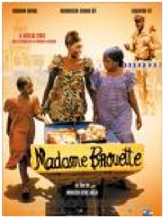
Single mother Mati toils daily by selling various goods at a nearby market, which she transports there via a large wheelbarrow -- prompting local residents to dub her "Madame Brouette." Having sworn off men since divorcing her abusive husband, Mati's example persuades her best friend Ndaxte to also leave her thuggish husband. Mati's vow toward men gets temporarily put on hold once she meets slick-talking policeman Naago and the pair begin a wild fling. Mati grows increasingly aware of Naago's corruption -- as well as his penchant for womanizing -- just about the same time she realizes she's pregnant with his child. As Naago and Mati's relationship turns sour, Mati is forced to take matters into her own hands once again, but Naago's criminal activities increasingly put Mati and her family's lives in danger -- forcing the determined woman to take drastic measures to save her family.

Mado (1976) 135 min

Simon Leotard, age 49, single, middle class meets Mado, age 22 and discovers she has a fresh, secret, pure character. Intrigued, he sees her often. He even meets her friends, specifically Pierre and Alex. ASsrumors fly, Jullian, Simon’s partner, falls into trouble with Lepidon, a former financier.

Mandat, Le (1968) 85 minutes

A money order from a relative in Paris throws the life of a Senegalese family man out of order. He deals with corruption, greed, problematic family members, the locals and the changing from his traditional way of living to a more modern one.

*Maria Chapdelaine (1983) 108 minutes

A young woman, living with her parents and siblings on a remote farm in harsh, picturesque northern Québec, has three suitors: a steady and unimaginative farmer, Eutrope, the Americanized and wealthy Lorenzo, who has sought his fortune in Boston, and François Paradis, a rough and virile logger who captures her heart despite the warnings of her parents and the village priest.

*Marius (1931) 130 minutes

César runs a bar along Marseilles' port, assisted by his 23-year-old son, Marius. Colorful characters abound: M. Panisse, an aging widower and prosperous sail maker; Honorine, a fishmonger with a sidewalk stall near the bar; her daughter, Fanny, who helps her sell cockles; and, various old salts. Friends since childhood, Fanny and Marius love each other, but Marius has a secret wanderlust: every ship's whistle stirs a longing for foreign lands. When M. Panisse seeks Fanny's hand in marriage and when a departing clipper needs a deckhand, Marius and Fanny must decide who and what they love most. César, with his generous, comic spirit, tries to guide his son.

Marius et Jeannette (1997) 105 minutes

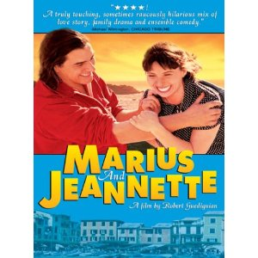
Pugnacious Jeannette lives in a convivial working class house in Marseilles, where she raises her two children with the meagre pay from her precarious job in a supermarket. When she attempts to steal two buckets of paint from a derelict cement works, she is caught red-handed by Marius, the limp guard who lives there. A relationship between Marius and Jeannette develops, but they are both hesitant to become emotionally committed. The unavoidable involvement of Jeannette's talkative, sometimes quarrelling, mostly cheerful neighbours, brings additional - sometimes decisive - twists to her relationship with Marius, and with her children as well.

MaRock (2005) 105 min


A Muslim girl and a Jewish boy fall in love. “For all the Romeos and Julietes of the world” Rita’s Morocco is full of car races, friendships, music, alcohol, first loves, and becoming adults. She will live life her way.

Métisse (Café au Lait) (1994) 94 minutes

This movie is about a young woman named Lola of mixed racial heritage (her mother is from Martinique and that's all we know for sure) who has been involved with two men whom she "loves". She becomes pregnant and brings both men together for the first time to hear the news in person. She informs them that she doesn't know which of them is the baby's father but that she intends to have her child regardless. The men in question are Felix, a poor white Jewish guy who loves rap music and Jamal, the black Islamic son of a wealthy diplomat. Both men vie for Lola's affections and brawl with one another, getting into racially-motivated disputes over which of them should be allowed to care for mother and child, and argue about who the real father is.

Molière (2007) 120 minutes
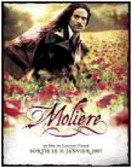
In 1658, playwright/actor Molière, having been given a theater in the capital by the King, is back in Paris after touring the kingdom of France with his company of players. One day, a young lady asks him to follow her to the deathbed of her mother... Thirteen years earlier, Molière already runs a troupe but goes broke and is thrown to prison. Fortunately, Monsieur Jourdain, a rich man who wants him to help him rehearse a one-act play he has written with a view to seducing a beautiful bright young widow, Célimène, covers his debt. As Jourdain is married to Elmire, and is the "respectable" father of two daughters, his design must remain secret so Molière is introduced into the house as Tartuffe, an austere priest...

Mon Oncle Antoine (1971) 104 minutes
Set in cold rural Quebec at Christmas time, we follow the coming of age of a young boy and the life of his family, which owns the town's general store and undertaking business.
(VHS & DVD copy – no Subtitles / DVD M & Copy – English Subtitles)

Monsieur Ibrahim (2003) 95 minutes
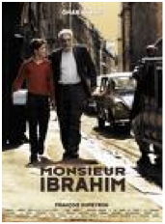
On a street called Blue in a very poor neighborhood in Paris, Monsieur Ibrahim is an old Muslin Turkish owner of a small market. He becomes a friend of the Jewish teenager Moises, tenderly nicknamed Momo, who lives with his father in a small apartment on the other side of the street. Monsieur Ibrahim gives paternal love and teaches the knowledge of the Koran to the boy, receiving in return love and respect.

Nana (1926) 120 minutes

A government official, Count Muffat, falls under the spell of Nana, a young actress. She becomes his mistress, living in the sumptuous apartment, which he provides for her. Instead of elevating herself to Muffat's level, however, Nana drags the poor man down to hers - in the end, both lives have been utterly destroyed.

Nelly & Monsieur Arnaud (1995) 103 minutes
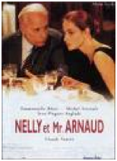
Nelly is underemployed, in debt, and married to a slacker. She meets Arnaud, a wealthy retired magistrate and businessman whose wife lives in Geneve with another man and whose children hardly speak to him. He offers to pay her debts, no strings attached. She leaves her husband and accepts Arnaud's gift. He then offers a job typing and editing his memoirs, which she takes. She is beautiful, amused, detached; he is observant and probing. She meets his youthful publisher, they begin a love affair. When that ends and it is also clear that her husband and she are irreconcilable, Nelly's delicate friendship with Arnaud is her refuge. Then his wife returns and things must change.

Noirs et Blancs en Couleur (Black and White in Color) (1977) 90 minutes

French colonists in Africa, several months behind in the news, find themselves at war with their German neighbors. Deciding that they must do their proper duty and fight the Germans, they promptly conscript the local native population. Issuing them boots and rifles, the French attempt to make "proper" soldiers out of the Africans. A young, idealistic French geographer seems to be the only rational person in the town, and he takes over control of the "war" after several bungles on the part of the others.

*Notre Dame de Paris (1956) 150 minutes

Today is the festival of the fools, taking place each year in the square outside Notre Dame. Among jugglers and other entertainers, Esmeralda, a sensuous gypsy, performs a bewitching dance in front of delighted spectators. From up in a tower of the cathedral, Frollo, an alchemist, gazes at her lustfully. Frollo orders Quasimodo, the deformed bell ringer and his faithful servant, to kidnap her. But when he comes close to her, he is touched by the young woman's beauty...

Papillon, Le (The Butterfly) (1973) 151 minutes
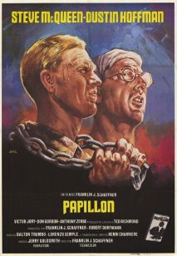
Based on the true story of Henri Charriere, also known as Papillon, which is French for 'butterfly' (the character even sports a large tattoo of a butterfly). A petty criminal, Papillon is wrongly convicted of murder and sentenced to life in a French penal colony in 'Guiane' (French Guiana, South America). Papillon is determined to escape but attempt after attempt meets with difficulty, resulting in eventual recapture. He continues his attempts to escape despite incarcerations in solitary confinement as punishment.

Paris je t’aime (2006) 110 minutes

Paris, je t'aime is about the plurality of cinema in one mythic location: Paris, the City of Love. Twenty filmmakers have five minutes each; the audience must weave a single narrative out of twenty moments. The 20 moments are fused by transitional interstitial sequences and also via the introduction and epilogue. Each transition begins with the last shot of the previous film and ends with the first shot of the following film, extending the enchantment and the emotion of the previous segment, preparing the audience for a surprise, and providing a cohesive atmosphere.

Pas sur la Bouche (Not on the Lips) (2003) 117 minutes

A musical drawing room farce set in Paris in October, 1925. Gilberte flirts with men but loves her husband Georges. He's negotiating a deal with an American, Eric Thomson, who turns out to be Gilberte's first husband from an annulled and secret stateside marriage. Along with her sister Arlette, Gilberte begs Eric not to tell Georges about the marriage. Meanwhile, a young artist, Charly, pursues Gilberte while Arlette tries to match him with the young Huguette, who loves him. Will Eric play along or try to re-win Gilberte's affection?

Persepolis (2007) 96 minutes

In 1970s Iran, Marjane 'Marji' Statrapi watches events through her young eyes and her family’s dream is fulfilled when the hated Shah's is defeated in the Iranian Revolution of 1979. However as Marji grows up, she witnesses first hand how the new Iran, now ruled by Islamic fundamentalists, has become a repressive tyranny on its own. With Marji refusing to remain silent at this injustice, her parents send her abroad to Vienna to study for a better life. However, this change proves an equally difficult trial with the young woman finding herself in a different culture loaded with abrasive characters and profound disappointments that deeply trouble her. Even when she returns home, Marji finds that both she and homeland have changed too much and the young woman and her loving family must decide where she truly belongs.

Petite Jerusalem, La (2005) 96 min

Tunisian-French Laura is a young woman that lives with her Orthodox Jewish family in the Jewish community in the suburbs of Paris. Her mother is a widow that left Tunisia; her sister Mathilde is having troubles in her marriage because she repressed her sexual desire based on her misunderstandings of the principles of her religion. Laura is an open-minded student of philosophy and works cleaning a school in the nightshift. While Laura feels a strong passion and desire for her Muslim Algerian colleague, her sister finds that her husband had an affair with a woman, and looks for an advisor that helps her to interpret the true meaning of love and the duties of a married woman.
Petite Lili, La (2003) 100 minutes

Mado is a successful actress who is spending the summer at her country estate with her boyfriend, Brice, a noted filmmaker who directed her latest picture. Also staying with Mado is her son, Julien, a budding experimental filmmaker with a combustible personality who is infatuated with Lili, a beautiful young woman whose family lives nearby. Lili is attentive but cool around Julien, who doesn't pay much heed to the attentions of Jeanne-Marie, the daughter of Mado's caretaker who has long held a torch for him. When Julien screens his latest film for Mado and her guests, it leads to a bitter argument between the two as her criticism of her son's work devolves into a series of personal attacks on one another. As Julien threatens to sever ties with his mother, Lili courts the attentions of Brice, while Jeanne-Marie defends Julien's work with little reaction from him.

Pièces d’Identités (1998) 93 minutes

The timeless story of an old king, his beautiful if wayward daughter, a dragon of sorts and the prince charming who rescues them; it even has a happy ending. At the same time, Ngangura's simple fable raises some of the most troubling issues of identity facing people of African descent in the ever-widening Diaspora of the late 20th century.

Pierrot le fou (1965) 112 minutes
Pierro escapes his boring society and travels from Paris to the Mediterranean Sea with Marianne, a girl, who is chased by hit men from Algeria. They lead an unorthodox life, always on the run.

Place Vendôme (1998) 117 minutes

The death of Vincent, the director of one of the prestigious jewelry shops on chic Place Vendôme, leaves his wife, Marrianne, at a terrible crossroads in her life. Her life has been marked by sadness. Though she does retain some of her grace and elegance, Marianne lives in a boozy stupor most of the time... until the day she discovers seven magnificent diamonds stashed away in her husband's hidden chest.

Porte sur le Ciel, Une (1988) 120 min
A young Moroccan woman, Nadia, who lives in France, returns to Morocco for the death of her father. She meets a young woman who reads the Quar’an for the burial ceremony revealing to her a culture she had rejected and her religion Islam, which she yearns for to balance herself. She convinces her brothers to turn their father’s house into a “zaouia” thanks to a treasure she found in the garden and there she becomes pious. She meets a man who falls in love with her. It paints a picture of Morocco, a crossing of cultures and civilizations…

Poupées Russes, Les (2005) 120 minutes

Xavier is now thirty. No longer a student, he is not yet a well balanced, fulfilled adult either. His career is unsatisfying: far from being the renowned novelist he aimed to be, he must be content with little jobs such as reporter or ghost writer. His greatest "achievement" in "literature" is his collaboration to the script of a corny TV soap! His sentimental life is not much better, riddled with one night stands and unfinished romances. It seems that when he seduces a woman beautiful outside and inside such as Kassia or Wendy he can't keep them. Will he ever bring his life into focus?

*Quartier Mozart (1992) 81 minutes

The story of 48 hours in a working class neighborhood in Yaoundé, Cameroon's capital. It recounts the education of a young schoolgirl, Queen of the 'Hood, still proud like a woman who has never known men. Maman Thekla, the local sorceress, helps her enter the body of a young stud, My Guy, so she can understand the real "sexual politics" of the quarter. After a series of comic adventures among the neighborhood's macho characters, Queen of the 'Hood concludes that she's going to have nothing to do with men unless they truly love her.

Reine Margot, La (1994) 162 minutes


The night of August 24, 1572, is known as the Massacre of St. Bartholomew. In France a religious war is raging. In order to impose peace a forced wedding is arranged between Margot de Valois, sister of the immature Catholic King Charles IX, and the Hugenot King Henri of Navarre. Catherine of Medici maintains her behind-the-scenes power by ordering assaults, poisonings, and instigations to incest.

Religieuse, La (The Nun) (2005) 155 minutes

A sadistic and jealous nun, “Sister Ursula”, victimizes a group of Catholic school girls. The girls drown the nun in a pool of "holy" water. Eighteen years later circumstances arise in which the nun’s spirit is released to take her revenge. She possesses the body of Eva, the daughter of one of her killers. In order for the Sister Ursula to be properly laid to rest Eva herself must be killed.

Resources Humaines (Human Resources) (2000) 100 minutes

The 35-hour work week has all of France in its thrall. This film turns it into a feature about economic and familial politics. Frank, a business school graduate, returns to his provincial hometown to take a management position in the factory where his father has been working for 30 years. First Frank makes the mistake of actually asking the workers on the assembly line for their opinions. Then upper management manipulates his findings to lay off employees. This creates a huge rift, not only between labor and management, but between father and son. A human morality tale that evokes paternal and filial love, and illustrates the personal risk behind political ideas.

Retour de Martin Guerre, Le (The Return of Martin Guerre) (1982) 122 minutes

As a young man, Martin Guerre leaves his farm, family, and wife. Years later, he returns a changed man. The village rejoices at his return. But after a disagreement with his uncle, the village questions Martin's identity.

Ridicule (1996) 102 minutes
In the periwigged and opulent France of Louis XVI, an unwitting nobleman soon discovers that survival at court demands both a razor wit and an acid tongue.

Robe Noire (Black Robe) (1991) 101 min

In the 17th century a Jesuit priest and a young companion are escorted through the wilderness of Quebec by Algonquin Indians to find a distant mission in the dead of winter. The Jesuit experiences a spiritual journey while his young companion falls in love with the Algonquin chief's beautiful daughter underneath the imposing and magnificent mountains. Dread and death follows them upriver.

Rouge Baiser (Red Kiss) (1985) 110 minutes

In 1952 Paris, Nadia, a 15-year-old French-Jewish Stalinist of Polish descent falls in love with Stephane, an older, apolitical photographer. She's torn between love and politics; he's worried (rightly) about her being under-age; and to make matters more complicated, her Polish mother has been reunited with her first love and Nadia's family may be split apart.

Rouge et le Noir, Le (the Red and the Black) (1997) 140 minutes

Sorel is a sensitive and intelligent youth who, seeing no road to advancement in the military after Napoleon's fall, endeavors to make his mark in the church. Viewing himself as an unsentimental opportunist, he sets out to win the affections of Mme de Renal, whose children he is employed to tutor. After spending time in a seminary, he goes to Paris, where he seduces the aristocratic Mathilde, the daughter of his second employer.

*Salut Cousin! (1996) 98 minutes

Alilo arrives in Paris, met by his hip cousin Mok. Alilo is to pick up a suitcase of dresses to smuggle back to Algiers for resale. He's lost the dressmaker's address and his boss is gone for five days, so he stays in the Moskova neighborhood of the 18th arrondissement with Mok. Mok makes rap music of Jean de La Fontaine's fables, invents fabrications of his own, is in debt to his bookie, and in love with a punk rocker. Alilo's old-country sweetness, in contrast with Mok's big-city neuroses, gets the attention of Fatoumata, a lovely African neighbor. Once Alilo gets the dresses, he must return to Algiers, but it seems he's only started to live: is there any way he can stay?

Samia (2000) 73 minutes

Samia is a pretty Algerian teenager whose family has settled in the French city of Marseilles. Her ailing father, strict mother, and overbearing brother, Yacine, struggle to uphold the rigid codes of their former culture and Muslim religion, but find it difficult when thrust against the looser environment of their new, modern city. Stuck in the middle of all this confusion and turmoil is Samia, who embraces the French way of life, yet confronts racism whenever she steps onto a bus. A seemingly endless onslaught of contradictions--namely, feeling like an outsider at every single moment--confuse Samia to the point that she is almost unable to find a release for her bottled up aggression. She must continue to live her life, waiting for a solution to her troubles, which never seems to come.

*Sugar Cane Alley (1983) 103 minutes

On the Caribbean island of Martinique, a young boy named Jose listens to stories of Africa told by an old sugar cane worker. After the old man dies, the boy writes the stories in his own words and submits them as a school essay. His telling is so eloquent that the schoolmaster accuses him of plagiarizing them from a book. Utterly humiliated, Jose flies from the school and goes downtown with the intention of getting into trouble. Fortunately, he does not get killed, injured or arrested, but he does come home very late to find his schoolmaster having tea with his grandmother.

Sur mes levres (Read my Lips) (2001) 115 minutes

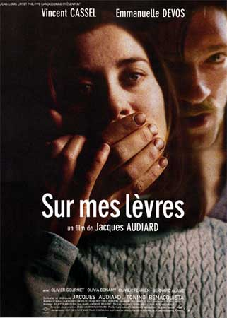
Young secretary Carla is a long-time employee of a property development company. Loyal and hardworking, first to arrive and last to leave, Carla is beginning to chafe at the limitations of her career and is looking to move up. But as a 35-five-year-old woman with a hearing deficiency, she is not sure how to climb out of her humdrum life, though she is confident in her own abilities. Into her life comes Paul Angeli, a new trainee she decides to hire. Paul is 25 years old and completely unskilled, but Carla covers for him when the need arises because of his other qualities - he's a thief, fresh out of jail and very good-looking. It's a case of good meeting bad.

Swann in Love (1984) 110 minutes

Elegant and educated bachelor, Charles Swann, moves in the most powerful and fashionable circles of Paris in the 1890's. When he falls in love with Odette de Crecy, a courtesan, his friends warn him against marriage. Proving himself a silly and socially-foul goose, Swann ducks his social responsibilities, Odette ensnares him, and he is gently but firmly cast out of society amidst everyone's great politeness.

Tatie Danielle (1990) 110 minutes

Auntie Danielle, supposedly in ailing health but in reality just a nasty old lady, lives with a paid housekeeper who she regularly abuses. When the housekeeper dies falling off a ladder, Danielle moves in with her great-nephew and his family. She continues using her nastiness to manipulate everyone into doing things her way until the family goes on vacation to Greece. The young housekeeper they hire to watch after her knows what Auntie is doing, and deals with her accordingly, and they begin forming respect for each other.

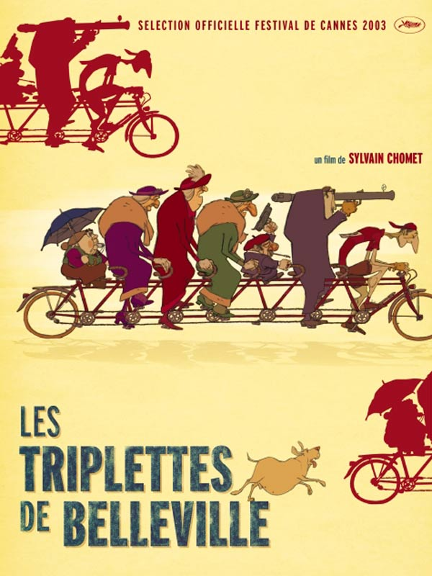
Triplettes de Belleville, Les (The Triplets of Belleville) (2003) 80 minutes

Madame Souza, an elderly French woman, instills in her grandson Champion (for whom she acts as guardian) a love of cycling. As a young man, he does become a dedicated road racer with his grandmother as his trainer. During a mountainous leg of the Tour de France in which Champion is racing, he goes missing. Evidence points to him being kidnapped. Indeed, he and two of his competitors were kidnapped, the kidnappers who want to use the threesome's unique skills for nefarious purposes. With Champion's overweight and faithful pet dog Bruno at her side, Madame Souza goes looking for Champion. Their trek takes them overseas to the town of Belleville. Without any money, Madame Souza and Bruno are befriended and taken in by three eccentric elderly women, who were once the renowned jazz singing group The Triplets of Belleville. The triplets help Madame Souza and Bruno try to locate and rescue Champion.

Vacances de Monsieur Hulot, Les (1953) 114 minutes

Monsieur Hulot goes on a holiday to a seaside resort, but accidents and misunderstandings follow him wherever he goes. The peace and quiet of the hotel guests doesn’t last very long with Hulot around, because although his intensions are good, they always turn out catastrophically.

Vagabond (1985) 105 minutes
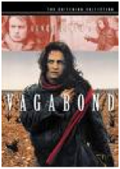
In winter in the south of France, a young woman is found frozen in a ditch. She's ill kempt, a vagabond. Through flashbacks and brief interviews, we trace her final weeks, as she camps alone or falls in with various men and women, many of whom project their needs onto her or try to give her life direction. She squats in an old house smoking hash with a man, falls for a Tunisian laborer and works beside him pruning grape vines, stays with a couple shepherding goats, meets an agronomist trying to save plane trees, gets tipsy with an old woman, and has an offer to appear in porn films.

* Valseuses. Les (1974) 117 minutes

Two whimsical, aimless thugs harass and assault women, steal, murder, and alternately charm, fight, or sprint their way out of trouble. They take whatever the bourgeois characters value: whether it's cars, peace of mind, or daughters. Marie-Ange, a jaded, passive hairdresser, joins them as lover, cook, and mother confessor. She's on her own search for seemingly unattainable sexual pleasure.

Veuve de Saint-Pierre, La (The Widow of St. Pierre) (2000) 120 minutes
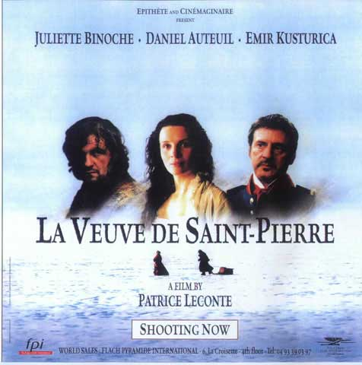
In 1849, in the Archipelago of Saint-Pierre et Miquelon, the drunken Ariel Neel Auguste and his partner Louis Ollivier kill for a futile motive (to see if he is fat or just big) the fishing boat captain Coupard. Nell, who stabbed the victim, is sentenced to die with his head severed in the guillotine while Louis is sentenced to hard labor. During the transportation to the prison under the custody of Captain Jean, there is an accident and Louis dies. While spending his days in the cell waiting for the guillotine and the executioner, Neel is invited by the captain's wife Mrs. Pauline to help her in her garden and becomes her protégé. Later he has a process of rehabilitation helping the locals in minor works and becomes very popular in the island. When he saves the building Café du Nord and her owner from sinking in the sea, his popularity increases and nobody but the governor and politicians of the council wants his death. Neel marries Eleontine Jeanne-Marie, but sooner he is informed that the ship Marie Galante has just left Martinique bringing a guillotine. Now the Governor and politicians need to find an executioner in the population to execute the sentence.

Vie en Rose, La (2007) 140 minutes
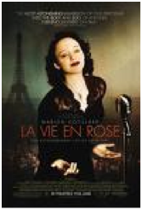
This film is an un-chronological look at the life of the Little Sparrow, Edith Piaf. Her mother is an alcoholic street singer, her father a circus performer, her paternal grandmother a madam. During childhood she lives with each of them. At 20, she's a street singer discovered by a club owner who's soon murdered, coached by a musician who brings her to concert halls, and then quickly famous. Constant companions are alcohol and heartache.

Vie est Belle, La (1987) 80 minutes


Kourou comes from a village to Kinshasa, the center of World Beat; music is in his heart and he has big dreams. He gets a job as a domestic for Mamou, the loud wife of a club owner, and he falls in love with Kabibi, a virginal young woman who wants to be a secretary. Meanwhile, Nvouandou, the club owner, childless after twenty years of marriage, wants a second wife and is determined to marry Kabibi. Mamou pretends to approve of the match, but behind her husband's back, she pushes Kabibi into the arms of Kourou.

Vie et Rien d’Autre, La (Life and Nothing But) (1989) 135 minutes
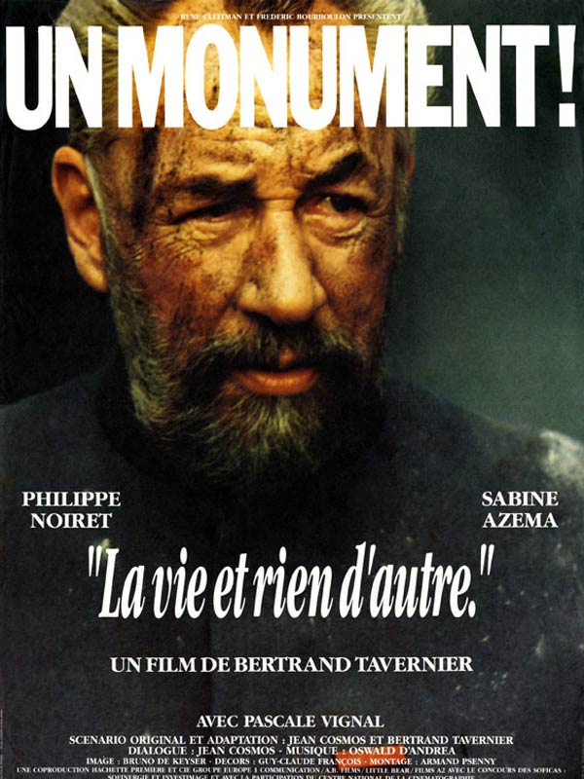
January, 1920. 350,000 French soldiers remain missing in action. Major Dellaplane tirelessly matches the dead and the wounded with families' descriptions. Honor and ethics drive him; he hates the idea of "the unknown soldier." Into his sector, looking for her husband, comes a haughty, politically connected Parisian, Madame Irène de Courtil. Brusquely, Dellaplane offers her 1/350,000th of his time, but as their paths cross and she sees his courage and resolve, feelings change. After he finds a surprising connection between her missing husband and a local teacher, Irène makes Dellaplane an offer. This man of action hesitates: has he missed his only chance?

Vie rêvée des anges, La (1998) 115 minutes

In Lille, two penniless young women with few prospects become friends. Isa moves in with Marie, who's flat sitting for a mother and child who are in comas following a car crash. Isa is out-going, unskilled, with hopes of moving south to warmer climates. Marie usually is either angry or detached. Then, Isa begins to visit the child in whose flat they live, during which Marie slowly falls for a rich youth. At first Marie keeps him at bay, then she falls in love with him. When Isa tries to warn Marie, their friendship flounders. How will Marie handle the inevitable? And once they lose the flat, where will they go?

* Visiteurs, Les (1993) 107 minutes

A medieval nobleman and his squire are accidentally transported to contemporary times by a senile sorcerer. He enlists the aid of his descendent to try to find a way to return home, all the while trying to cope with the cultural and technological changes distinguishing his time from ours.

*Wesh wesh, qu’est ce qui ce passe ? (2001) 83 minutes

Kamel, a young man from the French ghetto, near Paris, is coming back to France. He was arrested for dealing drugs, spent five years in jail, and was banned from France for two years. He tries, with his family's support, to find a job and live a normal life. But nothing's normal in the ghetto.

*Xala (1975) 123 minutes

It is the dawn of Senegal's independence from France, but as the citizens celebrate in the streets we soon become aware that only the faces have changed. White money still controls the government. One official, Aboucader Beye, known by the title "El Hadji," takes advantage of some of that money to marry his third wife, to the sorrow and chagrin of his first two wives and the resentment of his nationalist daughter. But he discovers on his wedding night that he has been struck with a "xala," a curse of impotence. El Hadji goes to comic lengths to find the cause and remove the xala, resulting in a scathing satirical ending.

Young Girls of Rochefort, The (1967) 120 minutes

Two sisters run a music and ballet school and in their spare time seek love and adventure. Their Mother runs a café in the Town Square, which is the eye of the romantic and dramatic storm that runs through the film. A young sailor mopes at the café dreaming of an ideal love, a local music merchant regrets his lost love, a carnival enters town and two of its members convince the sisters to put on a spectacle. As the film reaches a hysterical and breakneck pace, lovers are lost and found, separated and reunited and the glittering, pastel glamour of the town of Rochefort plays a starring role.

Zou Zou (1934) 92 minutes

As children, Zouzou and Jean are paired in a traveling circus as twins: she's dark, he's light. After they've grown, he treats her as if she was his sister, but she's in love with him. In Paris, he's a music hall electrician and she's a laundress who delivers clean underwear to the hall. She introduces him to Claire, her friend at work, and the couple fall in love. Jean conspires to get the show's star out of town and for the theater manager to see the high-spirited Zouzou perform. When Jean's accused of murder and Zouzou needs money to mount his defense, she pleads to go on stage. Her talents may save the show, but can anything save her dream of a life with Jean?

