SAINT MARY’S COLLEGE

GUIDE TO LEAVE REPORTING APPROVALS

LEAVE REPORTING

Administrative employees of Saint Mary’s College report their time off via Leave Reporting through PRISM. Administrative staff will report their absences via Leave Reporting as their absences occur. Monthly time reporting is no longer necessary. Requests for time off must still be approved in advance by the administrator’s direct supervisor.

Supervisors of administrative staff will be notified of the time reported by their administrative staff via PRISM as it is approved for the updating of leave balances by Human Resources. An e-mail message will be received by the supervisor advising him/her that a leave report has been made. The supervisor must review the time report as indicated below to discontinue receiving the e-mail message.

APPROVER RESPONSIBILITIES

- Upon e-mail notification of a leave report, enter PRISM.
- Review all submitted leave reports in detail.
- Notify Human Resources if there are any errors.
- Add comments to document changes you may to a submitted timesheet.
- Designate and train at least one Proxy to perform your responsibilities in your absence.

ACCESSING THE LEAVE REPORT SUMMARY

- Type https://inb.saintmarys.edu:444/ into your web browser to open PRISM or access PRISM via the Saint Mary’s @ home page.

- Click on the Enter Secure Area line.

- In the User ID box, type your Saint Mary’s Banner ID.

- In the PIN box, type your personal identification number (PIN).

- Click the Login button.

- Click the Employee tab. You will then see the screen below.

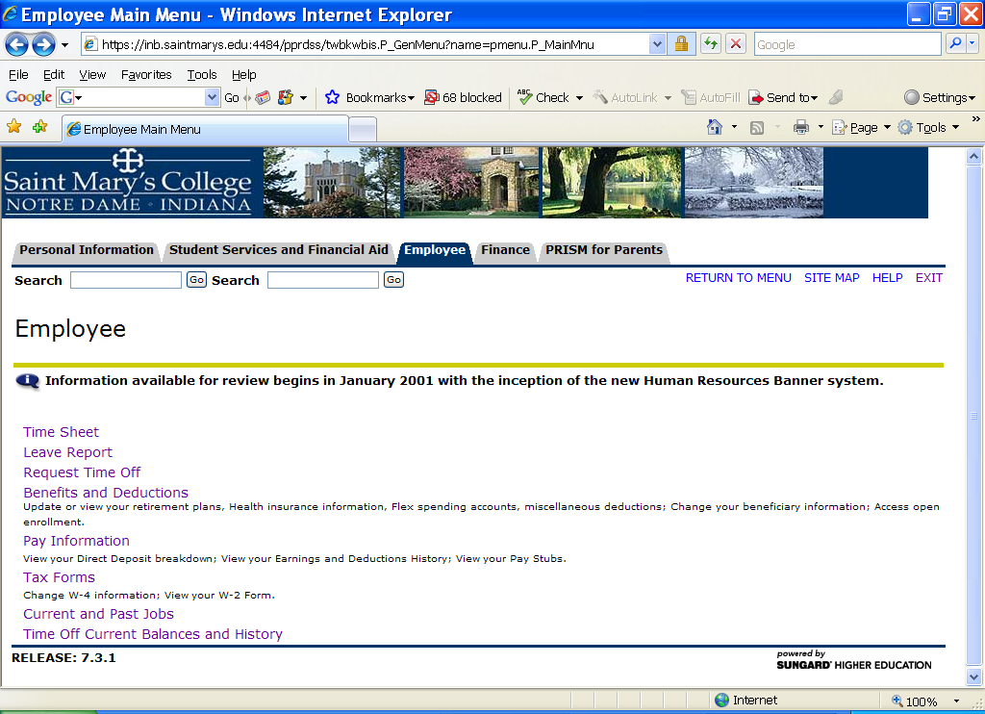

- Click the Leave Report link on the left side of the window.

- Under My Choice, verify that the dot for Approve or Acknowledge Time is selected.

Note: If you’re acting on behalf of another Approver, select the appropriate choice from the Act as Proxy dropdown box.

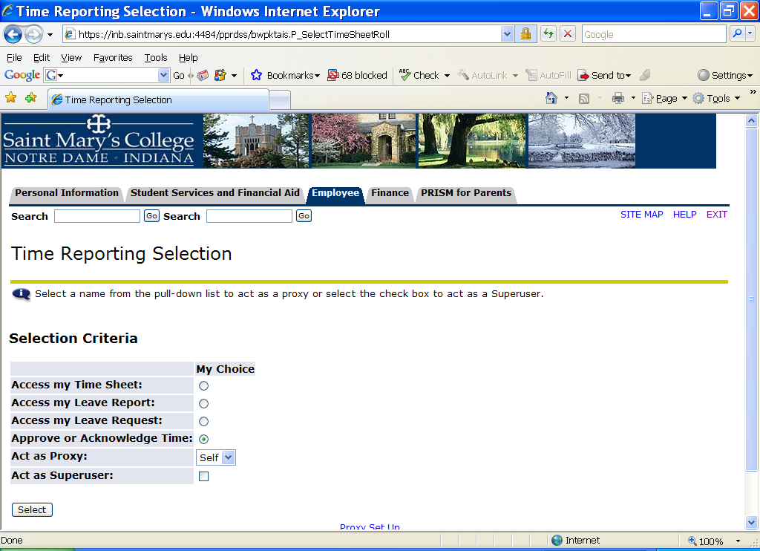

- Click the Select button.

- From the Leave Period dropdown box, select the leave period.

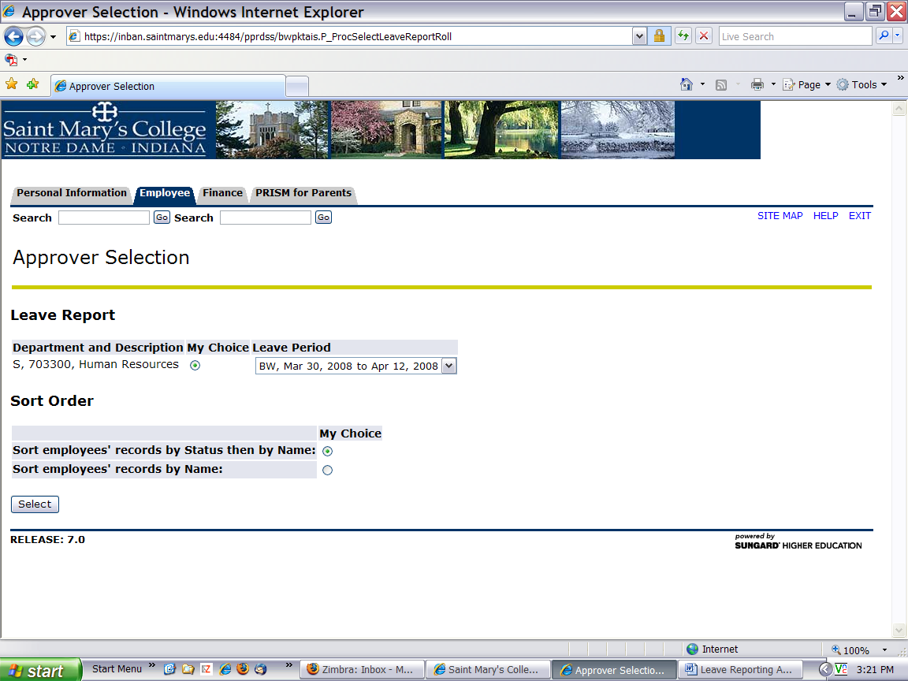

Select the Sort Order type.

Sort Order
 | My Choice
Sort employees' records by Status then by Name: | 
Sort employees' records by Name: | 
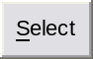

- Click the Select button.

REVIEWING A LEAVE REPORT

- On the Department Summary page, click the employee’s name in the Name and Position column.

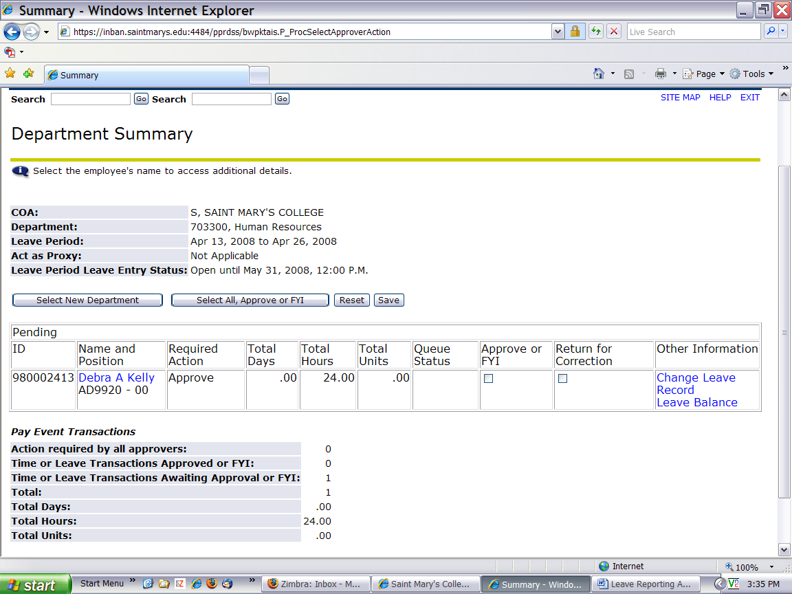

- Review the submitted Leave Report in detail. Be sure to scroll down to view all information.

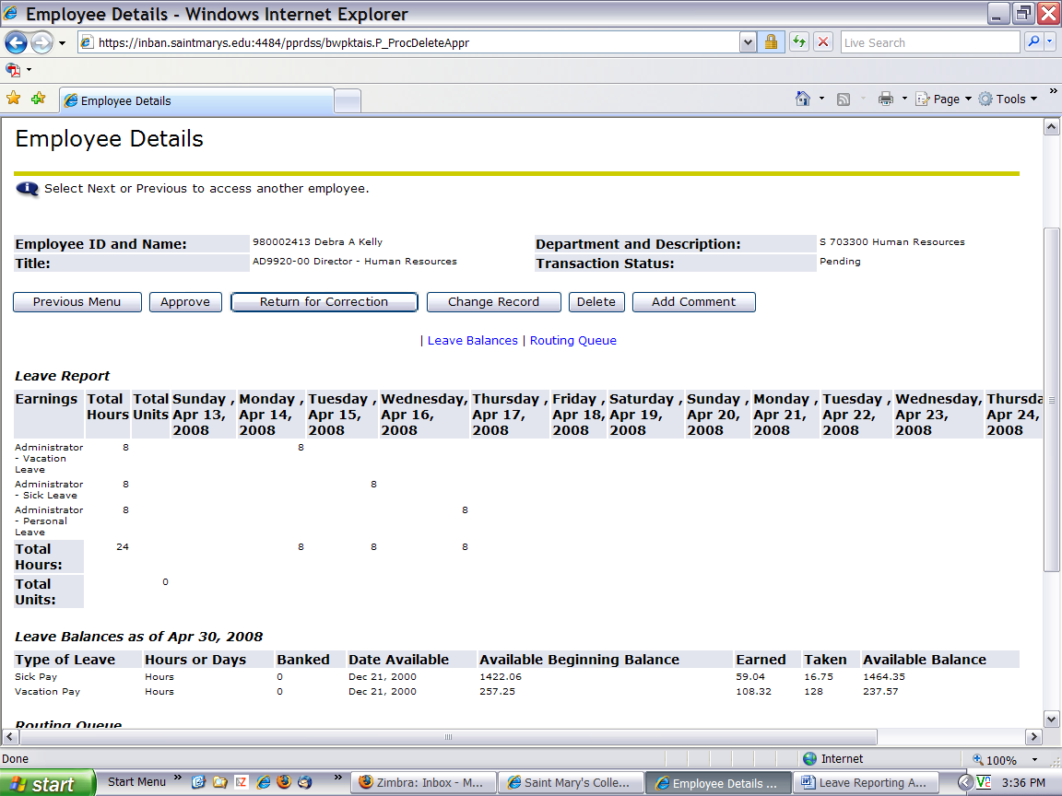

- Click the Acknowledge button at the bottom of the screen.

Note: The page will refresh and display a message that the timesheet was approved.

The time sheet was approved successfully.

- Click the Previous Menu button.

Note: Review of the Leave Report can be done on the Approver’s Summary Page without reviewing the actual Leave Report. To acknowledge the Leave Report at this level, click on the Approve or FYI box. However, as noted in Step 2 above, all Leave Reports should be reviewed in detail.

5. Exit PRISM.

6. If there is an error on the Leave Report, Human Resources must be contacted to make a correction.
DESIGNATING A PROXY

A proxy is a person who can act as an Approver if you’re not available. To set up a proxy, do the following:

- On the Timesheet/Leave Request/Proxy page, in the Selection Criteria area, click the Proxy Set Up link.

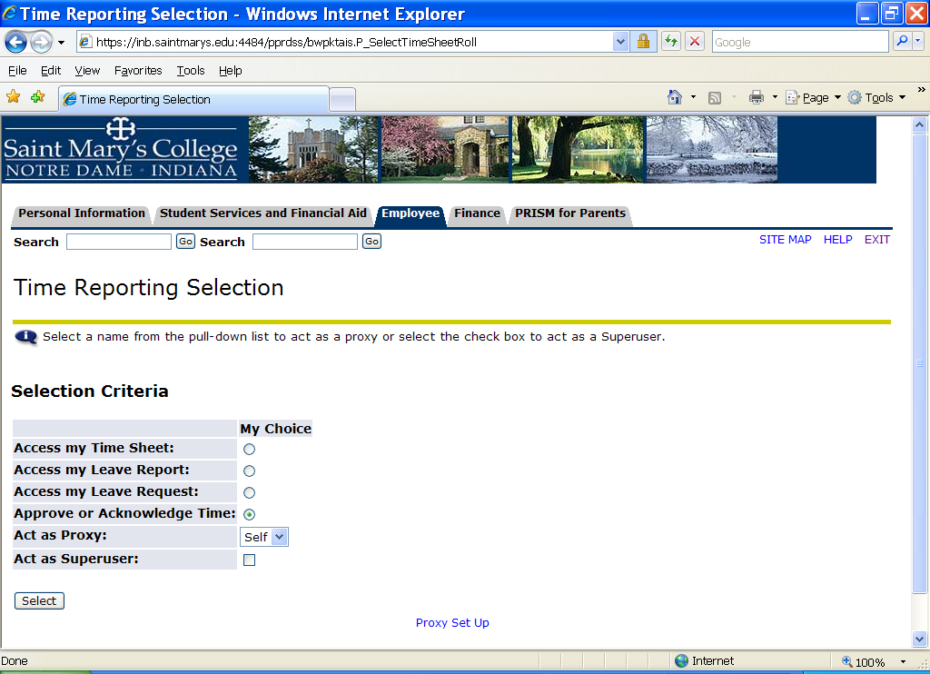

- From the Name dropdown box, click the name of the person you want designated as a proxy.

Note: Any current PRISM user can be a Web Time Entry approver proxy.

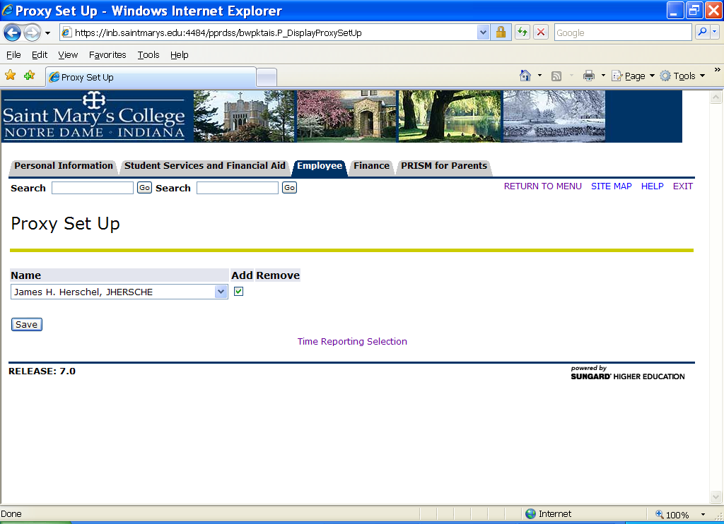

- Click the checkbox under Add.

- Click the Save button.

- Click the Time Reporting Selection link to return to the Timesheet/Leave Request/Proxy page.

