To turn the projector on:
Locate the touch-screen black box (next to computer or on the wall between the blackboard and the windows – none in 145B: push “on” button on black tower)
Tap the screen to turn the box on, tap again to turn the projector on
Wait (up to 5 min if first time on that day. TIP: You may wish to log into the computer while you wait, as logging in to the computer will also take up to 5 min).
To use the Computer:
Log in (your SMC user name and password)
Wait (up to 5 min)
To project the image from the computer onto the projector screen: make sure “local PC” is selected on the touch-screen black box.
TROUBLESHOOTING:
projector is projecting a blue screen → try “laptop” option on touch-screen box. If still nothing, try “local PC” option again. If still nothing, check connection between black to white cord connections in the back of the computer.
Projector is projecting only the background, no icons or windows → click on the “apple” icon -> System Preferences -> Display Preferences -> Arrange Tab-> Click on “mirror” box.
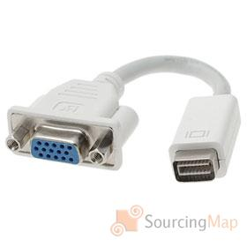
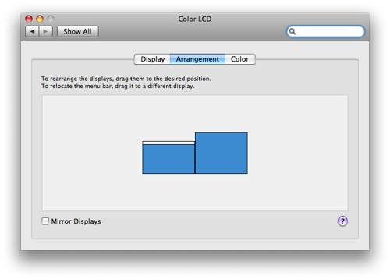
To use your own Laptop:
Connect your laptop to spare connection and switch to “laptop” on touch-screen box (in 148, there is only one connector, so you must disconnect first the computer before connecting your laptop, and keep option on “laptop”)

To use DVD or VHS player:
Select “VHS/DVD” option on touch-screen box. Follow instructions on VHS/DVD tower.
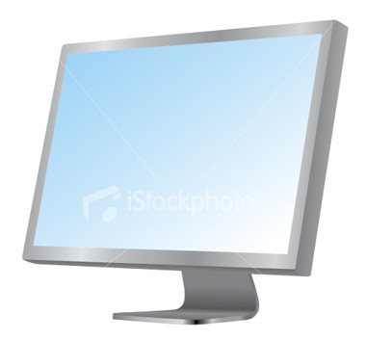
TIP: For DVDs, use the computer – insert DVD on right side of the screen, title facing you, laser-side facing away from you – if you put it in inversely, it will get stuck! DVD will automatically start playing. Options to play, pause, fast-forward, etc will pop-up and hide-away on the bottom part of the screen. You can also click-hold the diamond and move the cursor forward or backward with the movie.

To use DocCam (document camera):

Select “DocCam” option on touch-screen box.
Turn on Doc Cam (Do not forget to turn OFF when done!)
Place document to be projected on flat black surface. You will see a small image of what is being projected on DocCam screen. DO NOT press any buttons around the screen unless you are an advanced user. You can zoom in by turning the knob at the top of the “arm”. You can add more or less light by pivoting the light. NOTE: DocCam usually adjusts to the amount of light automatically for the best picture – give it a few seconds to auto-adjust. Check projection on projection screen.
TIP: Do you have transparencies you used with the old-fashioned projector that you don’t want to lose? Simply place a white sheet under your transparencies onto the DocCam. You can still use your erasable pens on your transparency for years of use!
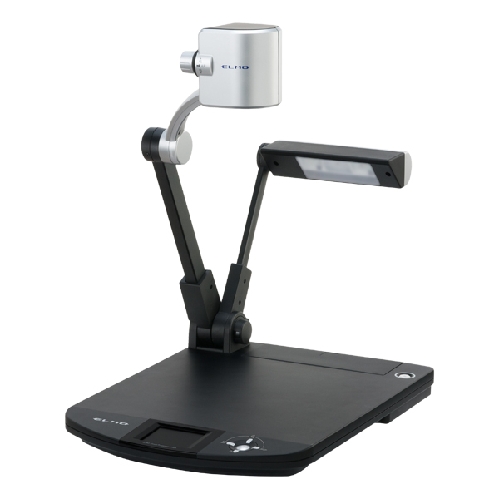
Zoom knob
Adjustable light

On/Off
Preview screen
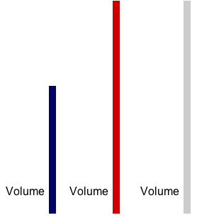
To adjust the Volume & Troubleshooting Volume:
The main volume is adjusted through the touch-screen black box.
- Hold your finger on the up arrow on right side of screen. You will see a black area shooting up (as if on a thermometer). It needs to be about ¾ high before you will hear anything. Adjust to preference between ¾ full and full.

Adjusting volume on the computer:
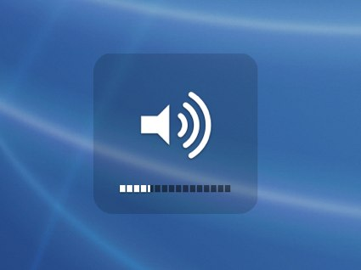
- If you are on Youtube or playing a DVD, there is a volume control on the screen.
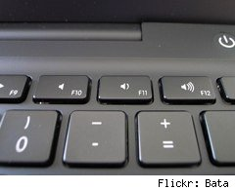

- You can also adjust volume from the keyboard.

- Check that the volume icon is also on and not muted.


- Check that the cord is plugged into the “headphones” outlet on the back of the computer – that connection to “headphones” is actually to the projector’s speakers.
- A bad connection can also be the source of not having volume – jiggle the cord that is plugged into the “headphones” outlet, and jiggle the white to black connection cords (see image next to “laptop”)
- As a last resort, you can unplug that “headphones” cord to get volume straight from the computer. It won’t be very loud, but that can be better than losing class time.

Adjusting volume on DVD/VHS players
- follow instructions on unit.

To adjust the brightness and/or color on projected screen:
On the computer, click on the “apple” icon -> System Preferences -> click on Display (Preferences) -> then click on “Color” tab. Highlight “VGA Calibrate” option and then click “Calibrate” button. Go through steps changing settings to suit your preference as you see projected on screen. You can then save your settings with your name.

